



Blooming Petals   
(A website for perfect décor and flowers)

Developed and Designed by:

Shabia Tanseer  
Huzaifa Mustafa  
Uzair Afzal  
Mubashir Manzoor  
Uzair Malik

**Table of Contents:**

**1.** **Problem Statement:** 3

2. Project Overview: 3

3. Objectives: 4

4. System Architecture: 5

5. User Interface Design: 8

7. Non-Functional Requirements: 21

8. Detailed Product Features: 21

9. Testing and Validation: 22

10. Conclusion: 24

1. **Problem Statement:**

The "Blooming Petals" project aims to create an online platform for selling various types of flowers and floral decorations. The company, currently advertising through pamphlets and digital marketing, seeks to expand by launching a website that will provide comprehensive information about the available products, allowing customers to view and purchase them easily. This document outlines the requirements, design, and implementation of the website, ensuring it meets the company's business goals.

### ****Project Overview:****

"Blooming Petals" is an e-commerce website designed to highlight and sell floral arrangements. The website includes sections for different flower categories, a detailed product comparison feature, downloadable product documents, and an integrated contact page with geolocation. The platform is designed to provide a seamless user experience, allowing customers to browse products by category, filter by type, and access detailed product information with ease.

### ****Objectives:****

* 1. **Primary Objectives:**
* Develop a user-friendly website where customers can easily find and purchase floral decorations.
* Provide detailed product information and comparison features to assist customers in making informed decisions.
  1. **Secondary Objectives:**
* Incorporate geolocation on the contact page to help customers locate the store.
* Offer downloadable product documents with detailed features.

### ****System Architecture:****

The system architecture of "Blooming Petals" is based on a multi-tier design, including the following layers:

* **Presentation Layer**: The front-end, developed using HTML, CSS, and JavaScript, provides the user interface and handles user interactions.
* **HTML:**

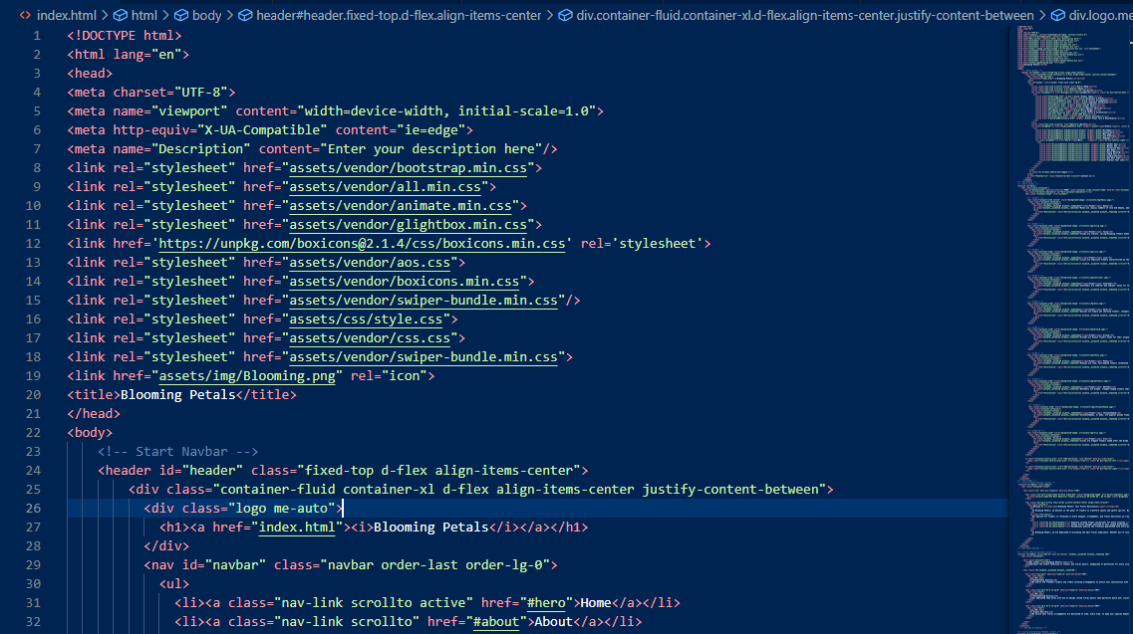

* **CSS:**

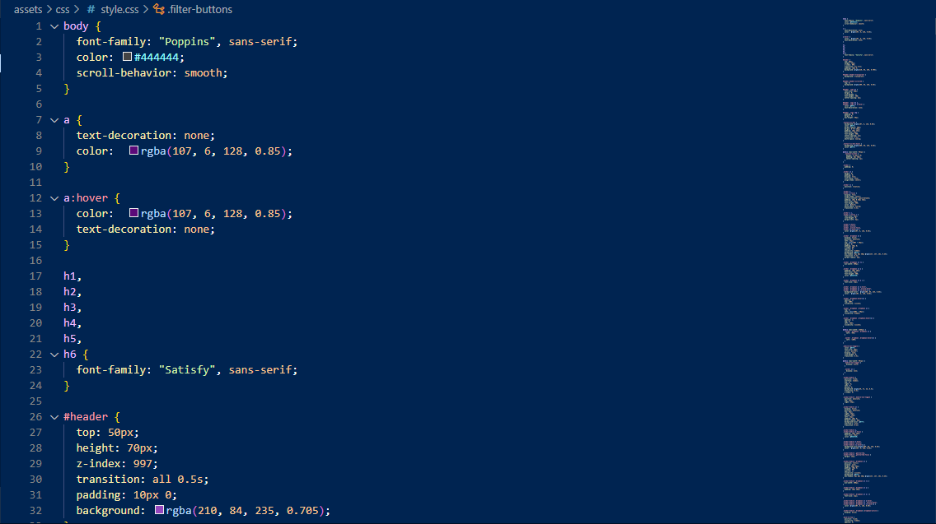

* **JAVASCRIPT:**

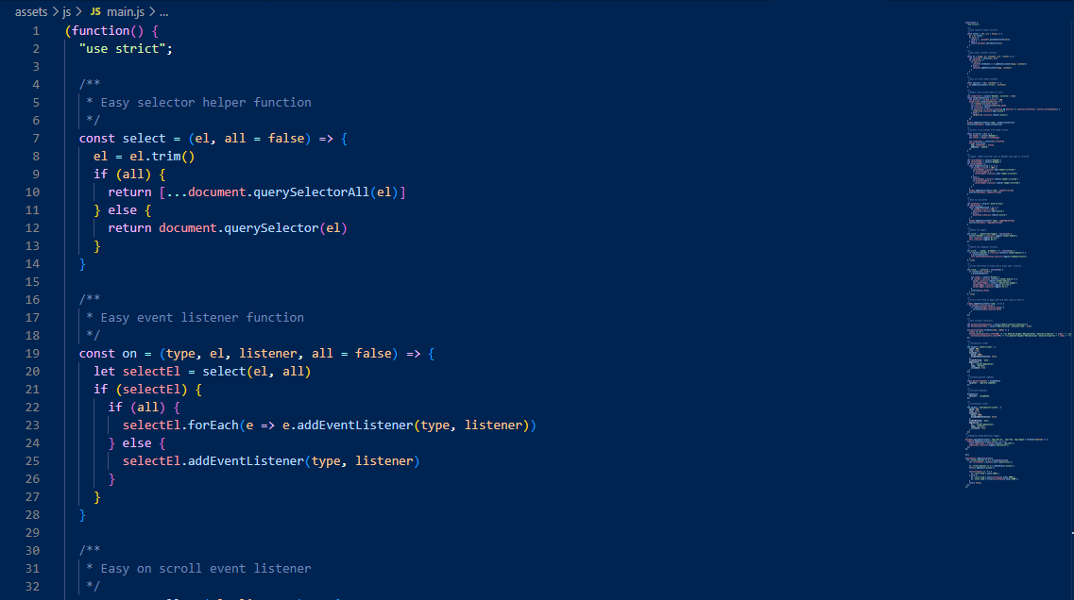

* **Business Logic Layer**: The back-end logic processes user requests, handles product filtering, and generates downloadable product documents.

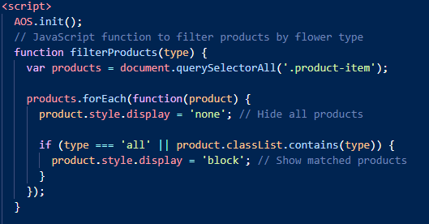

* **Data Layer**: The database stores product information, user data, and comparison details.

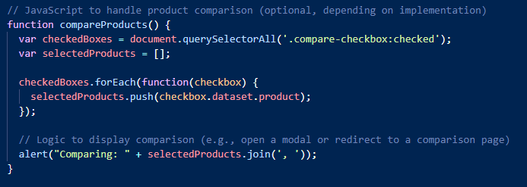

### ****5. User Interface Design:****

* **Wireframes**: The UI design includes a homepage with navigation to various flower categories, product pages with filtering options, and a detailed product view.
* Homepage With Navigation to various flower categories:

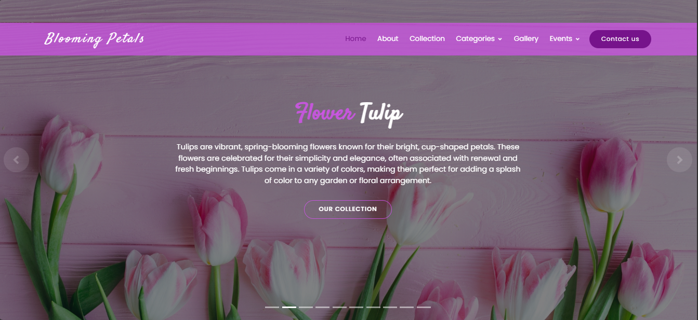

* Product Pages with filtering option:

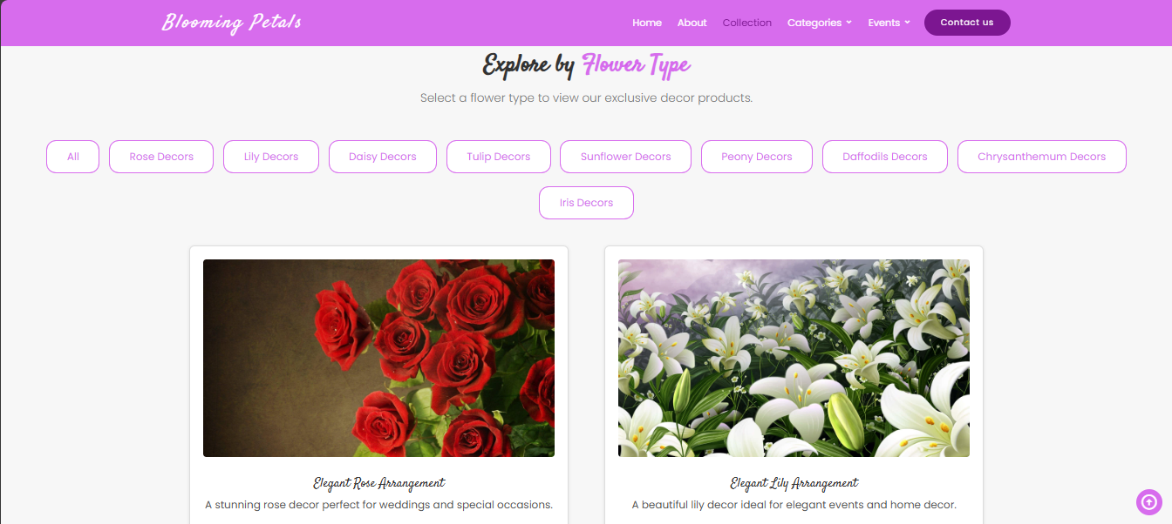

* Detailed product view:

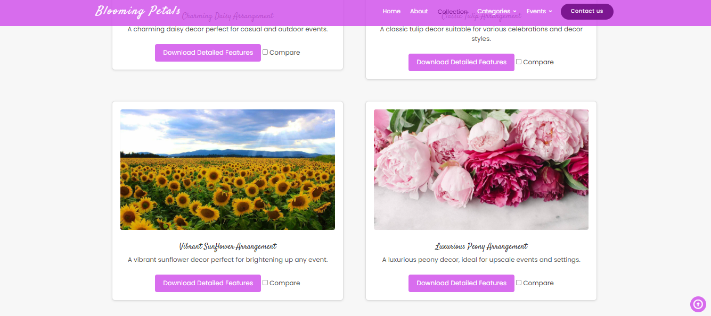

* **User Experience (UX) Design**: Emphasis on ease of navigation, accessibility, and providing a visually appealing interface that aligns with the floral theme.

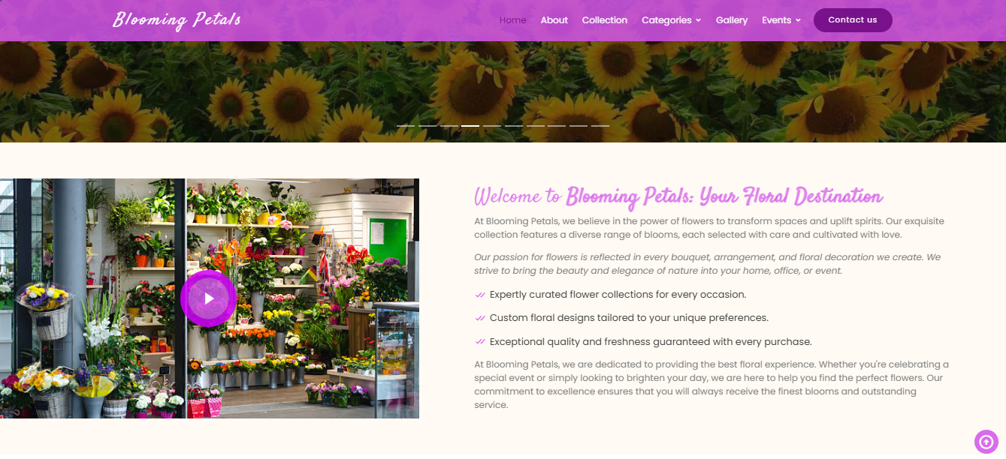

* 1. **Functional Requirements:**

The Web site is to be created based on the following requirements:

1. The Home Page should be created with sections, graphics and with a suitable logo.

* Sections:

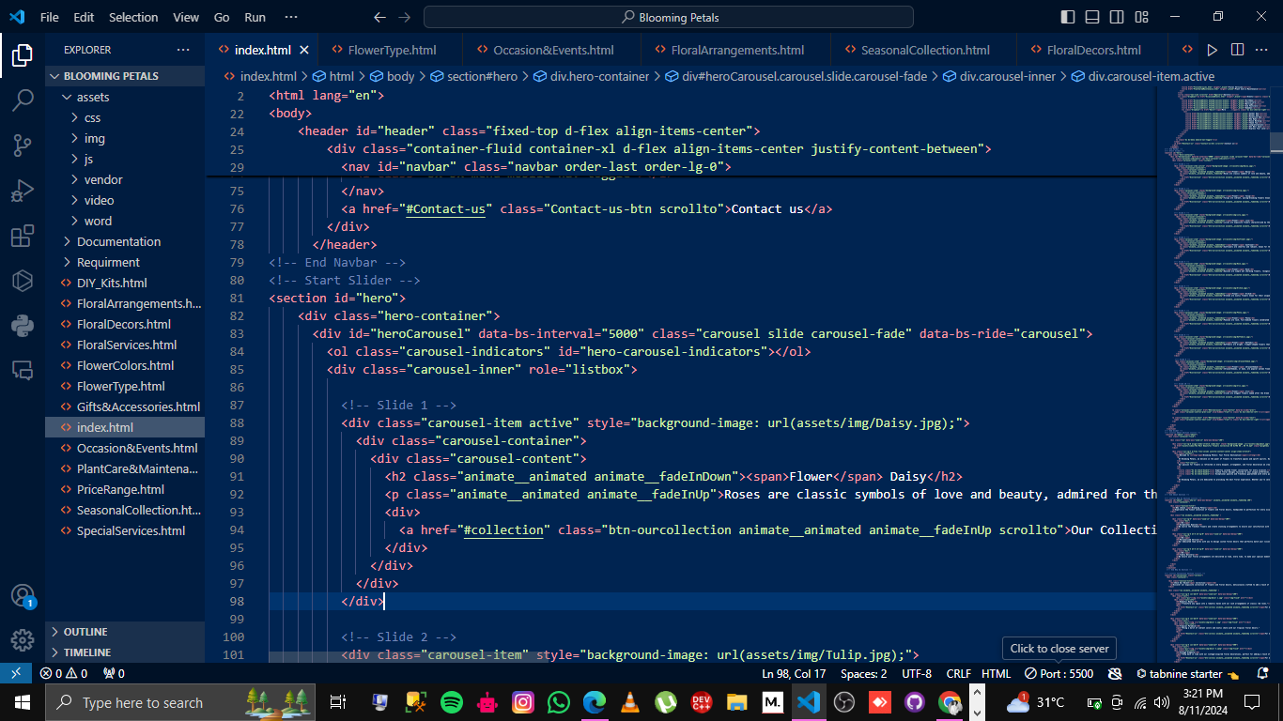

* Graphics:

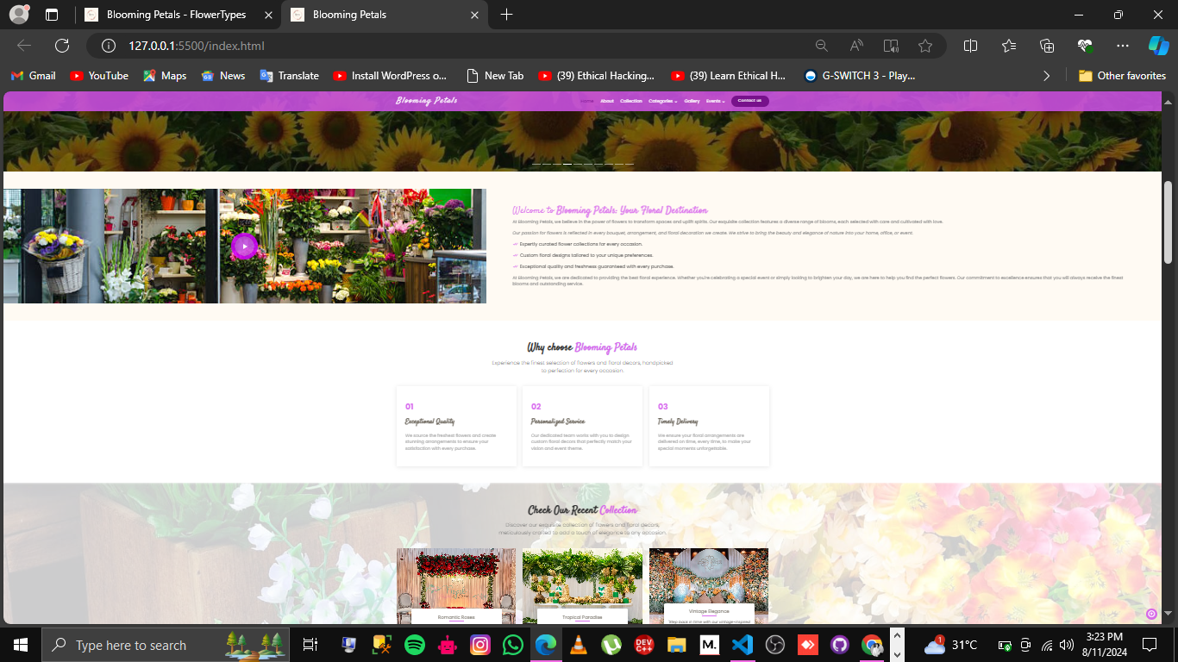

* Logo:



1. Home Page should contain details of different flowers/floral decors with suitable images.

* Information of different flower with images:

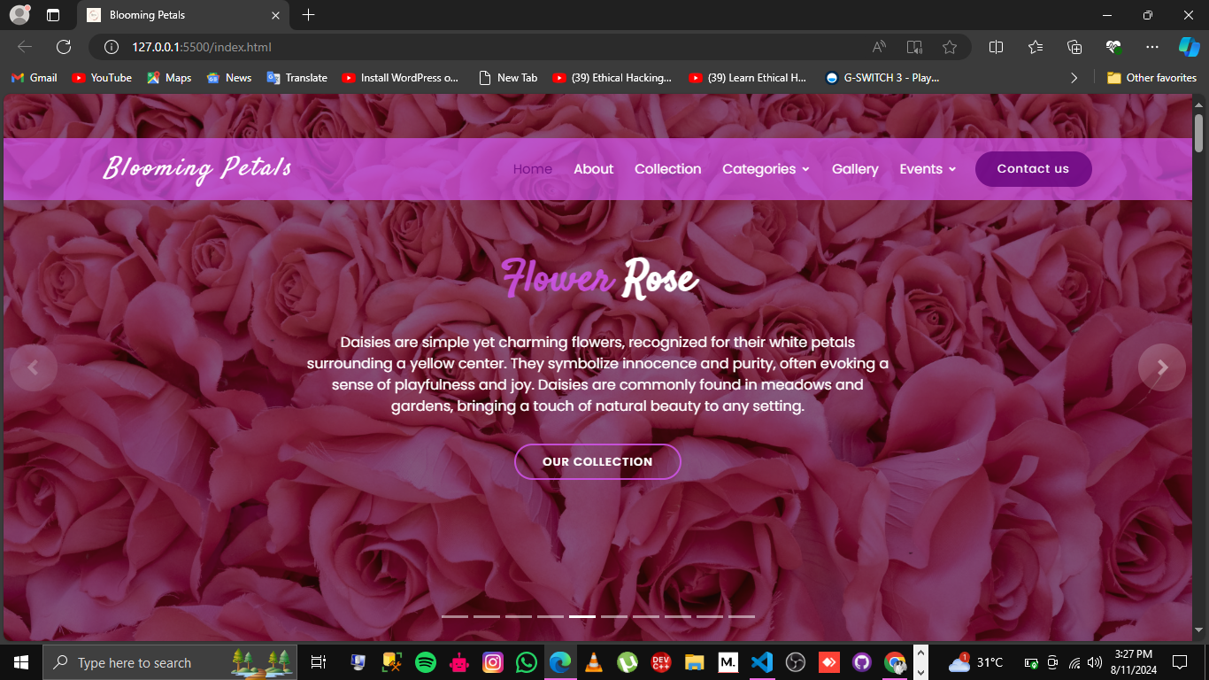

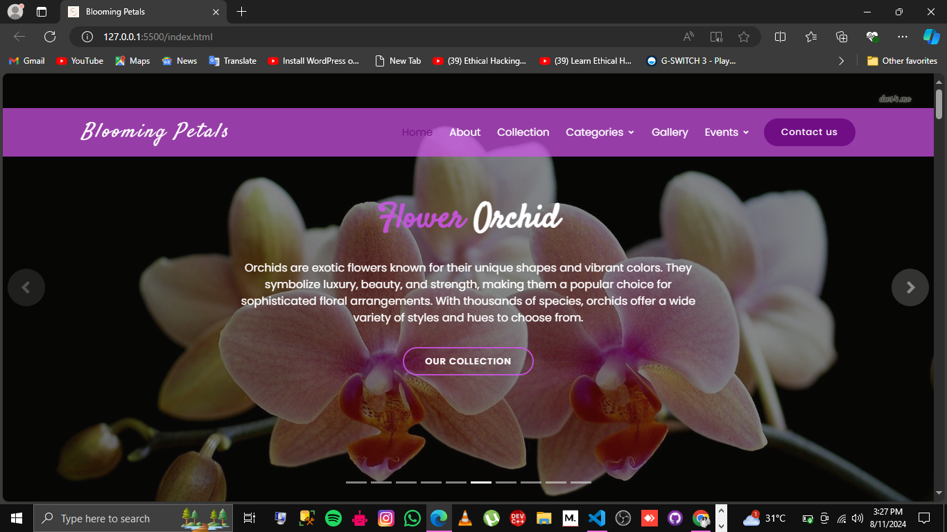

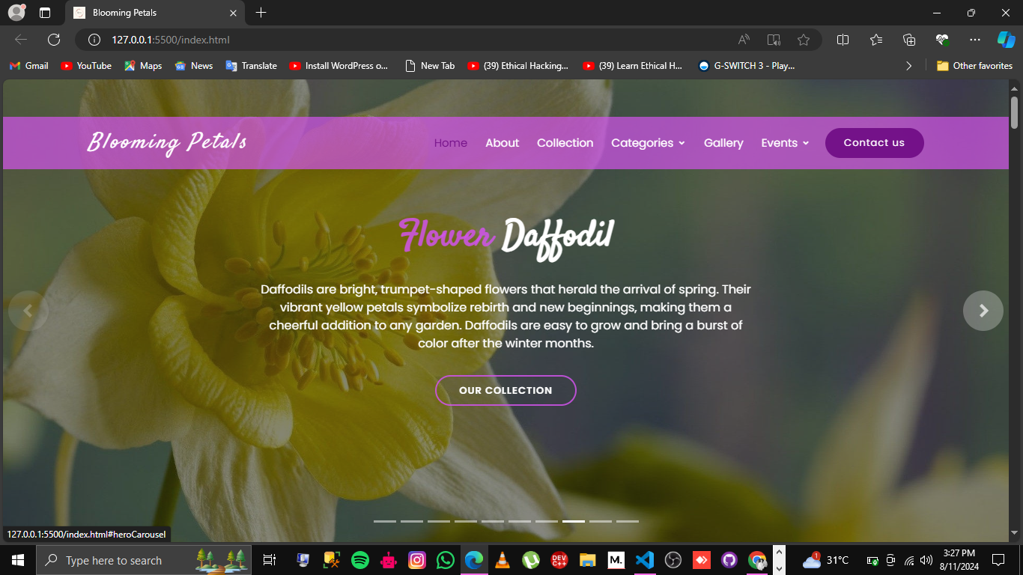

1. The site should display a collection which will contain the options for brief introduction about the various floral themes/decorations available, location of the shop and any other information if required.

* Collection Option:

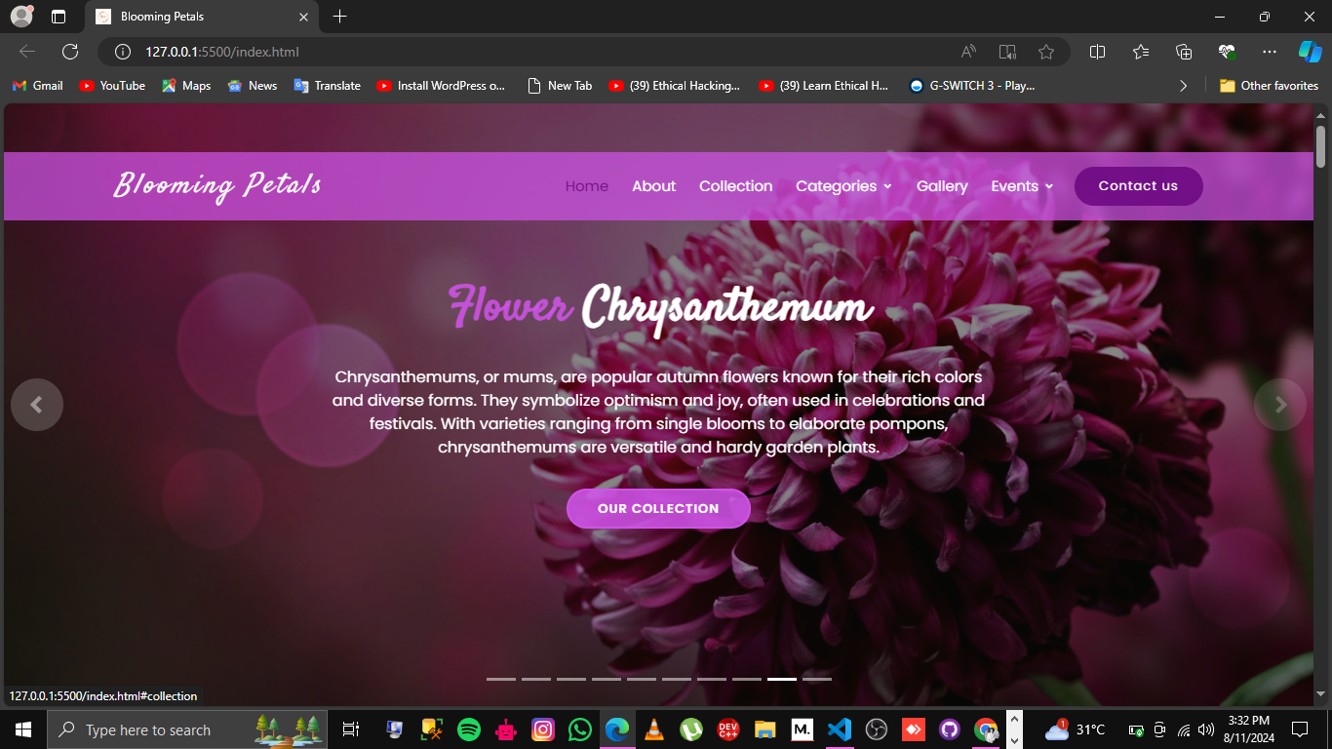

* After pressing this button, you will find the brief introduction about floral decors and theme.

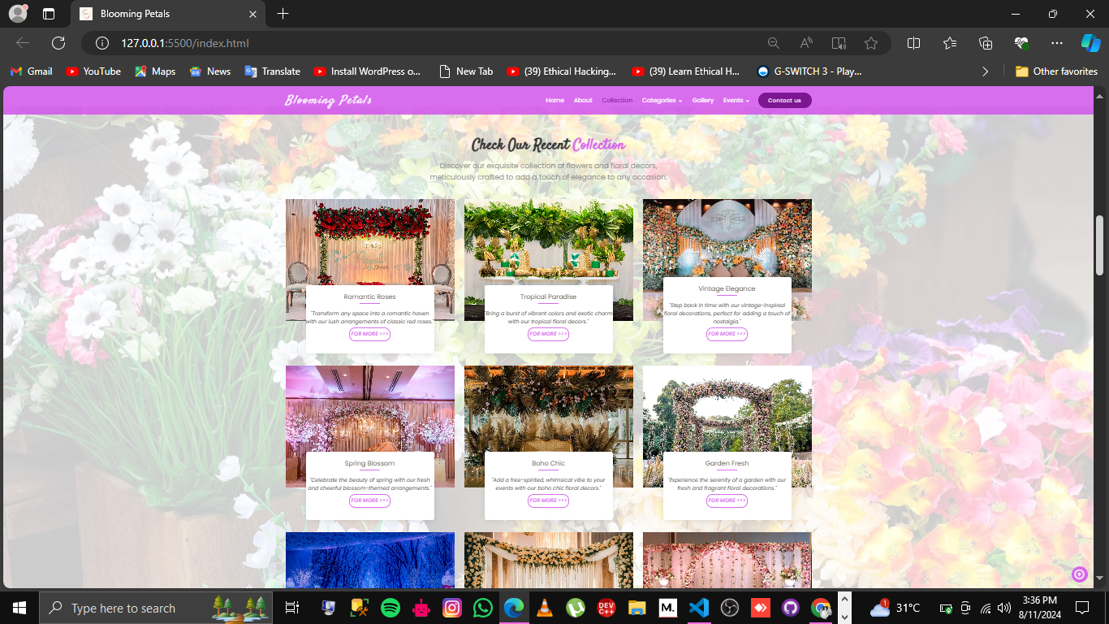

* After pressing (For more) Button you will find the location of the shop.

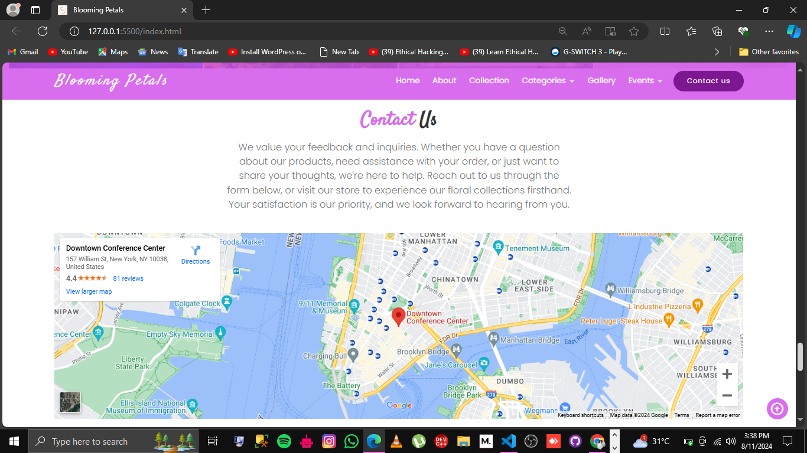

1. The information about products should be presented in two ways:
   1. Information should be available category wise, wherein user can click on a particular category and should be able to view all the products related to the category available with complete information. E.g.: Category can be "Birthdays", "Anniversaries", " Marriages" etc. with suitable sub-categories being defined.

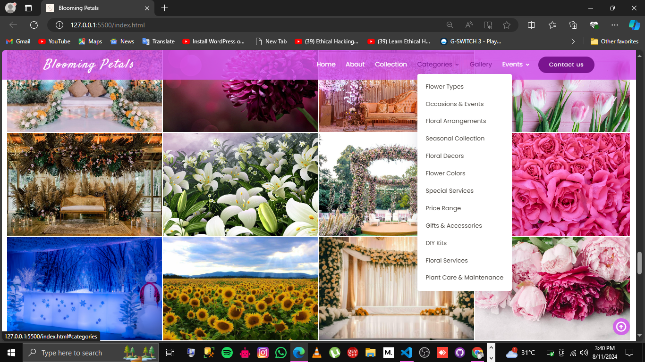

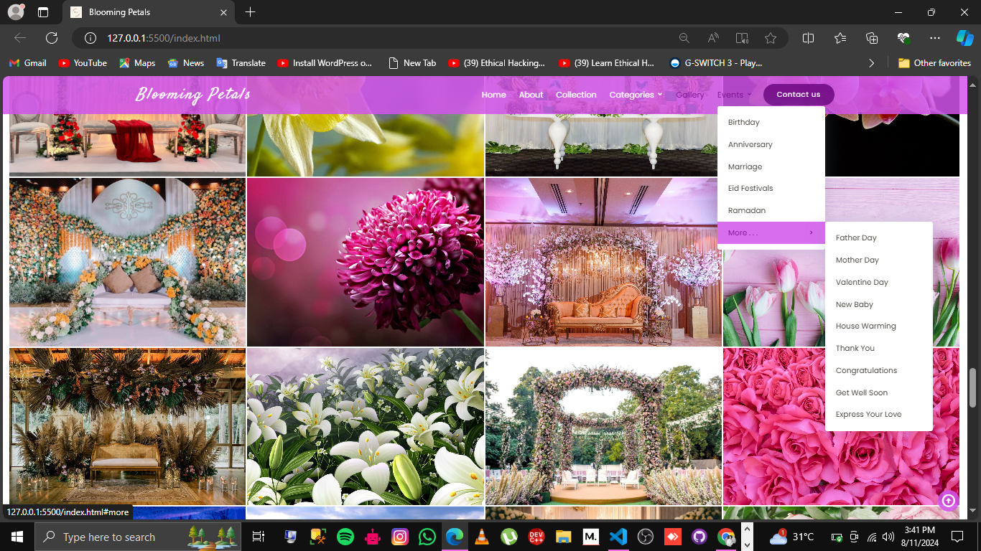

* 1. Information should be categorized according to the type of flowers like if a User wants to see only "Rose decors" or any other particular flower products then he/she can click on a Link/button/menu etc. and can see only that products.

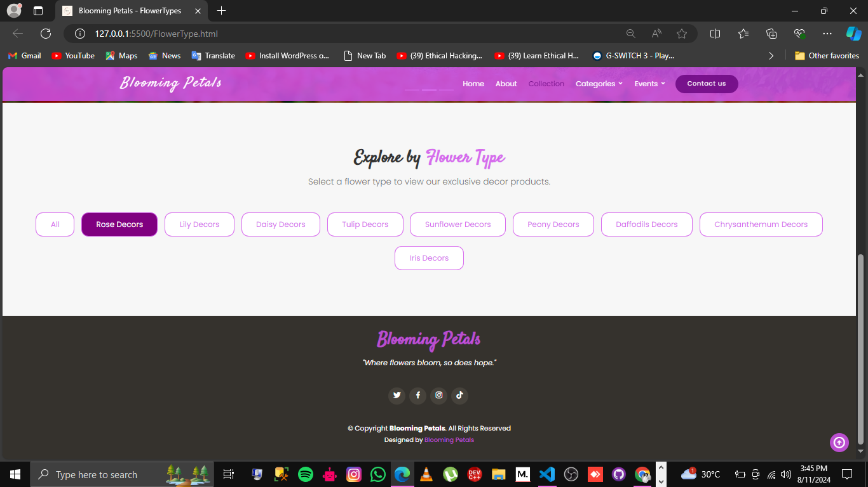

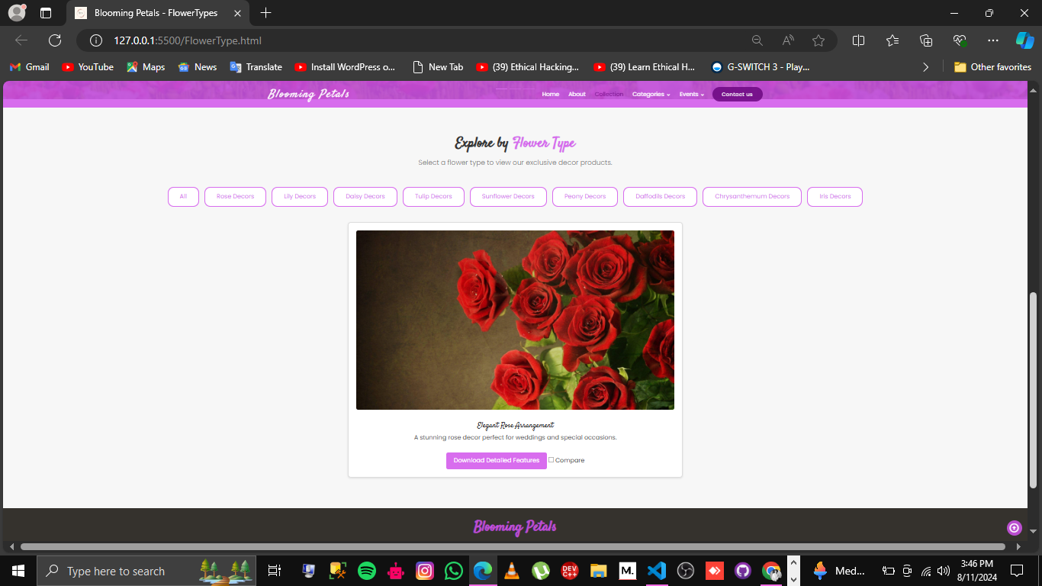

1. When a user selects any particular flower, a list of products for that brand will be displayed.

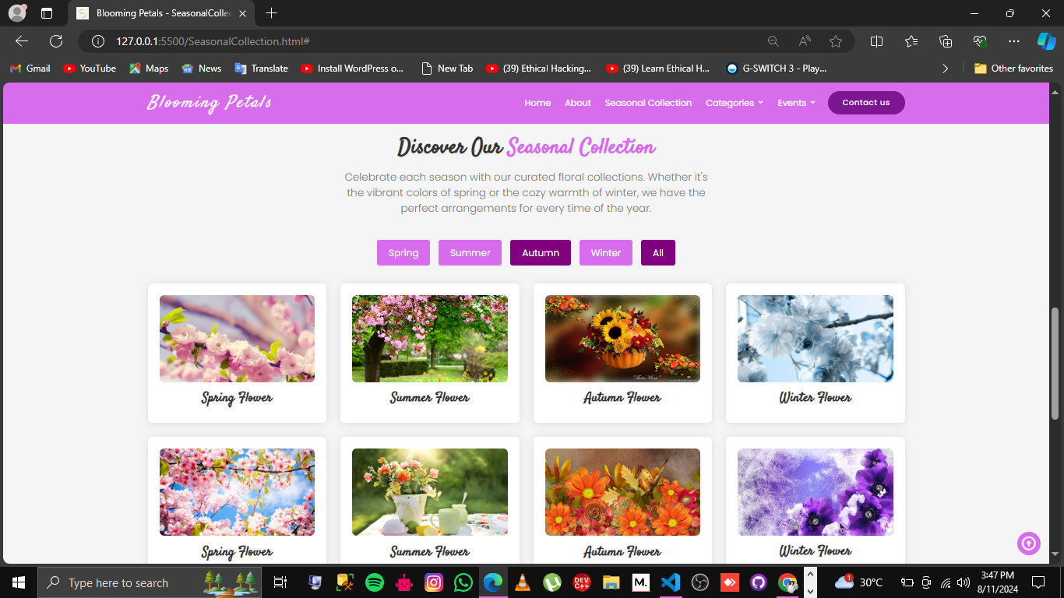

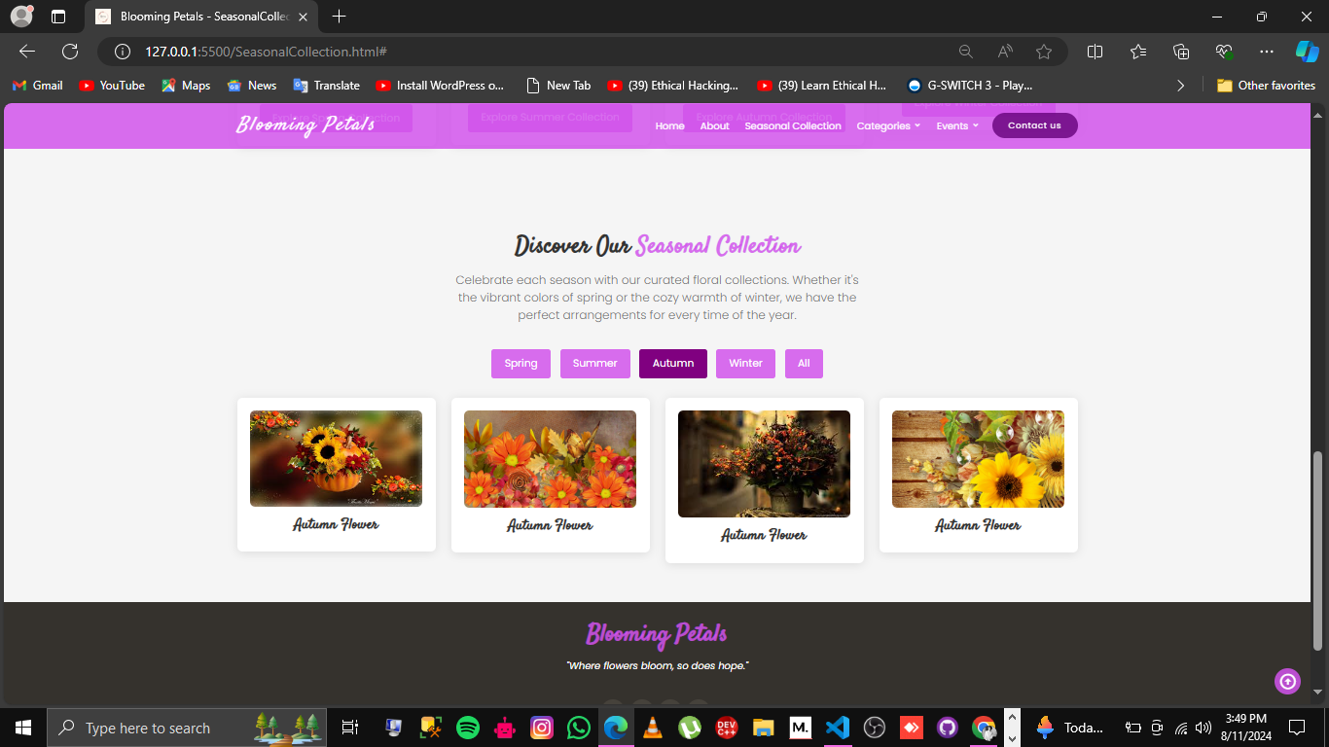

1. A brief summary of individual products should be displayed on the Web Page along with the product but detailed Features should be stored in Individual Word documents, which can be downloaded or viewed by the User who wishes to see the same.

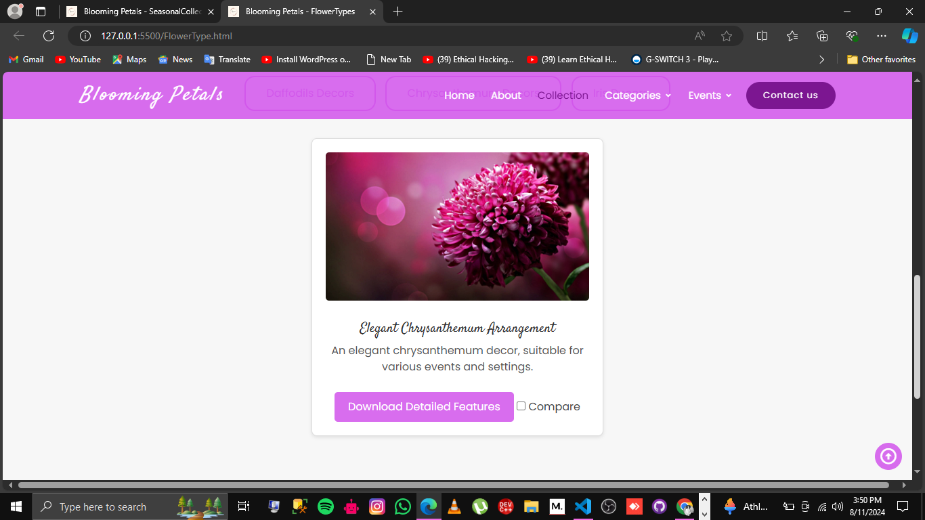

1. The user should also be able to compare the various products of different as well as similar categories.

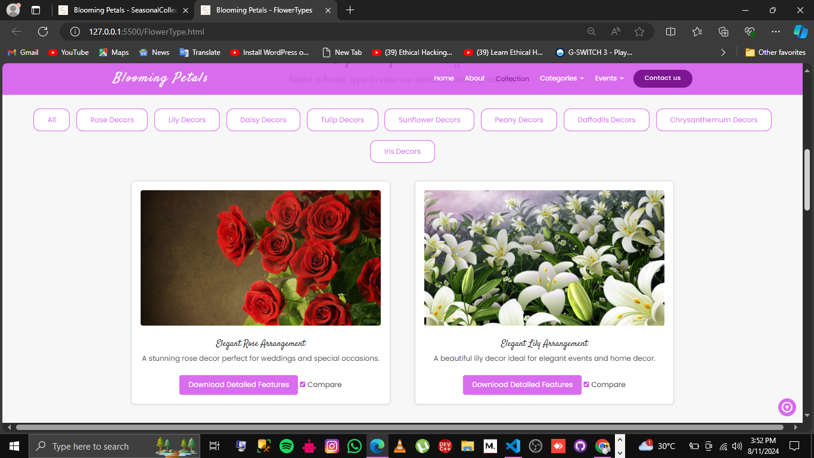

1. The Web Page has a "Contact Us" page, which will have the Address of the company along with the mail address while using Geolocation API (e.g. Google Maps) and the mail address when clicked will invoke the local mail client from where they can send an email.

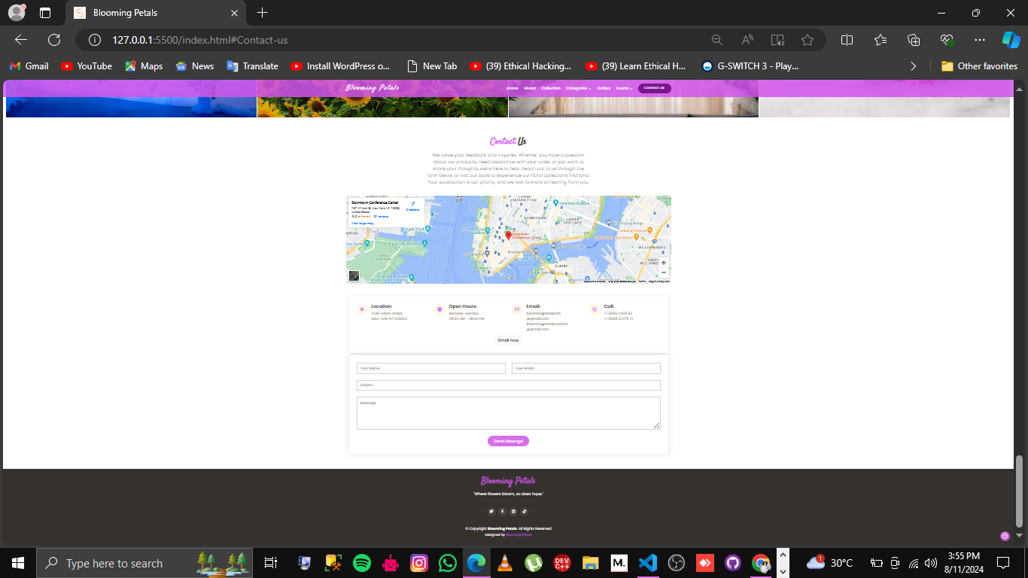

* The mail address when clicked will invoke the local mail client from where they can send an email.

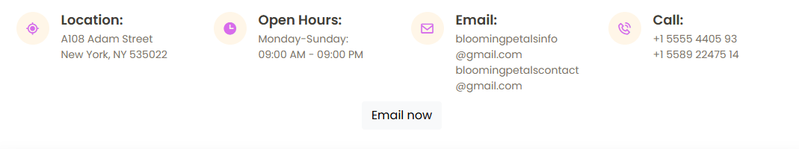

### ****Non-Functional Requirements:****

* **Performance**: The website should load within 3 seconds and handle multiple concurrent users without slowdowns.
* **Security**: Implement SSL for secure transactions and protect user data.
* **Usability**: The website should be intuitive, with consistent navigation and accessible design.

### ****Detailed Product Features:****

Provide detailed descriptions for each flower type, including key features, suitable occasions, and care instructions. These details are available for download as Word documents.

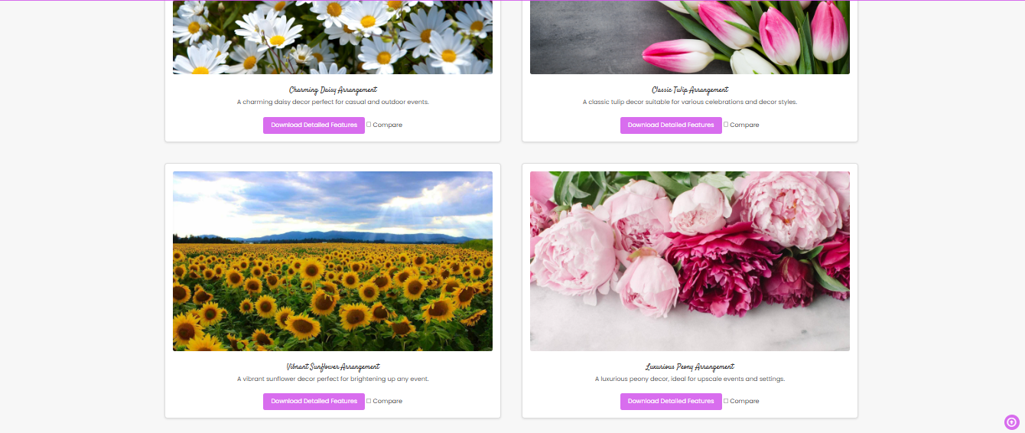

### ****Testing and Validation:****

**Test Cases**:

* Test the filtering functionality to ensure it correctly displays products based on user selection.

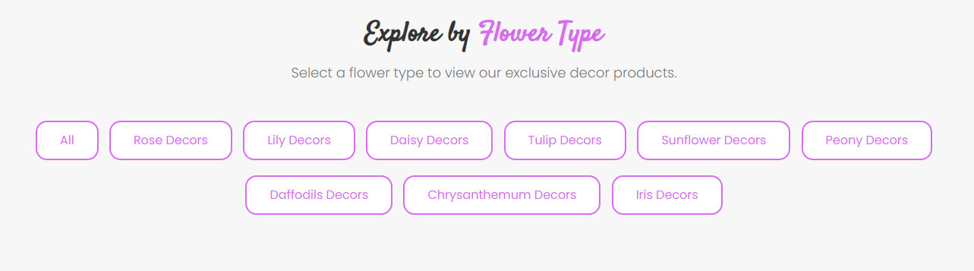

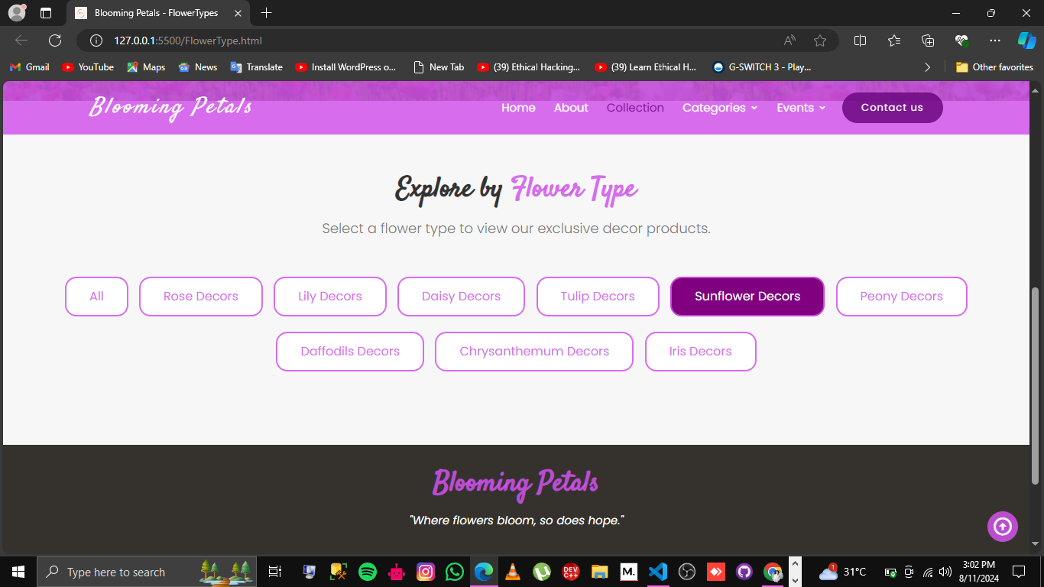

* Test the comparison feature for accuracy.

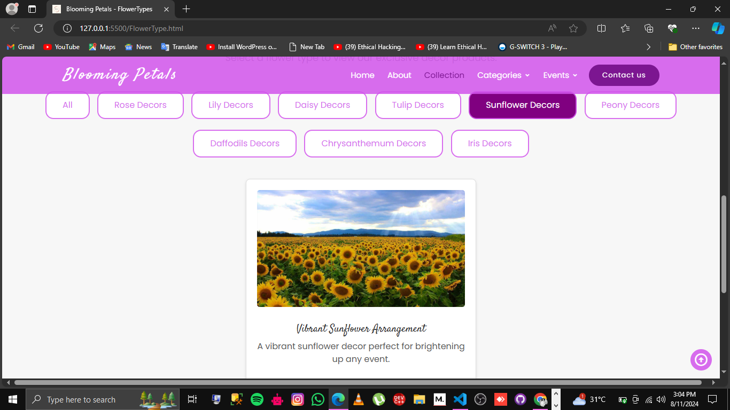

* Validate all downloadable documents for correct content.

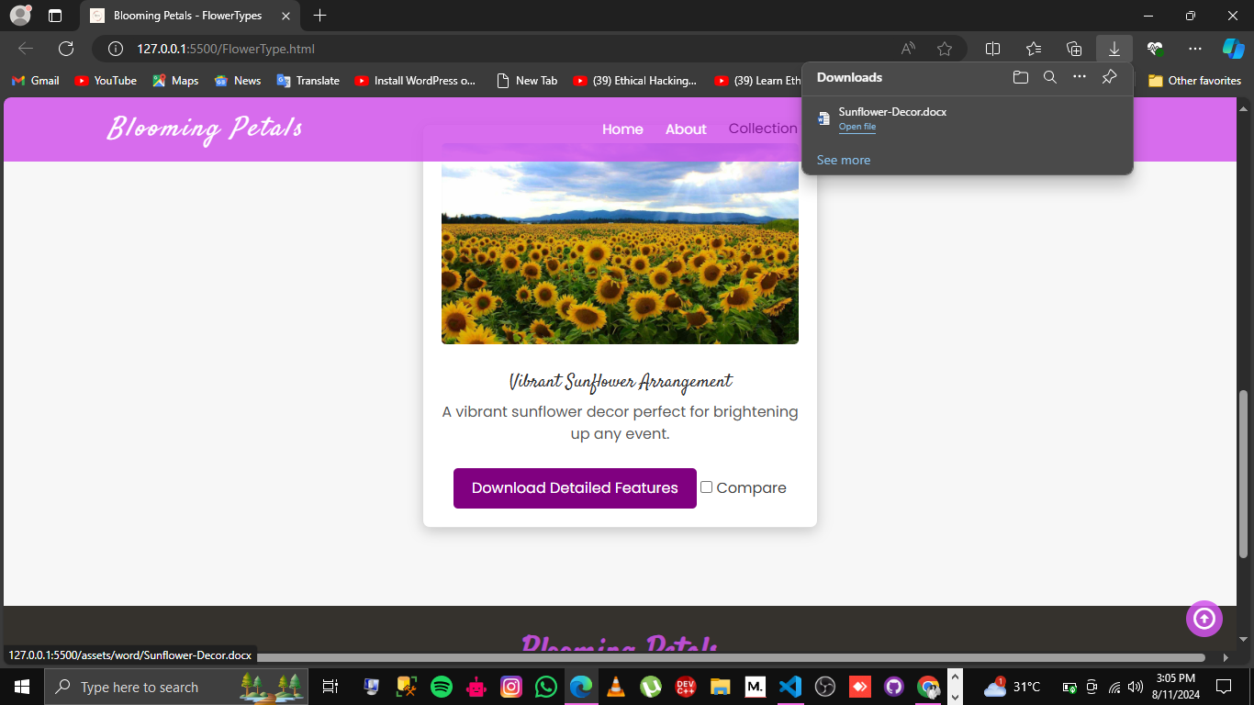

### ****Conclusion:****

Summarize the project's success, highlighting key features such as the filtering system, detailed product pages, and overall user experience. Suggest potential areas for future enhancements, such as adding an online payment system or integrating social media sharing options.